Project Tracker

Iteration #3 Plan

10/27/2014 – 11/9/2014

# Revision History

|  |  |  |
| --- | --- | --- |
| **Author** | **Date** | **Description** |
| M. Rudner | 11/1/2014 | Initial Release |
| M. Sunderland | 11/1/2014 | Initial Release |

# Objectives

The purpose of this iteration is to make our web application more aesthetically pleasing, added a log-in page, improved deleting and enforced permissions depending on logged-in user’s role. We also followed the principle of DRY (Don’t-Repeat-Yourself) design by creating an HTMLBuilder helper class.

# Use Cases

The following use cases are involved in this iteration:

* UC001: Submit a project idea
* UC002: View a table of submitted project idea – The basic flow of this use case will be implemented.
* UC004: Delete a project idea
* UC005: Edit Projects

# Task Schedule

|  |  |  |  |  |  |  |  |
| --- | --- | --- | --- | --- | --- | --- | --- |
| **Story ID** | Task | Effort | | Completion Date | | Owner | **Status** |
| **Est.** | **Actual** | **Est.** | **Actual** |
| S01 | Design UI for log-in page | 1 hour | 1 hour | 10/31 | 11/6 | Suenaga | Finished |
| S01 | Create SQL table for users | 30 minutes | 1 hour | 10/31 | 11/6 | Ranney | Finished |
| S01 | Create controller for authentication | 1 hour | 1 hour | 10/31 | 11/6 | Withee, Suenaga | Finished |
| S01 | Enforce permissions depending on logged in user’s role | 4 hours | 4 hours | 10/31 | 11/6 | Suenaga | Finished |
| S01 | Bug: Remove school list, status list, and user list | 1 hour | 1 hour | 10/31 | 11/6 | Suenaga | Finished |
| S21 | Fix CSS width issue | 1 hour | 1 hour | 10/29 | 10/28 | Rudner, Suenaga | Finished |
| S21 | Worked on “view list” aesthetics | 2 hours | 2 hours | 11/1 | 11/6 | Suenaga | Finished |

# Task Pictures

## UI log-in page:

## 

## Improved aesthetics for “View List” page:

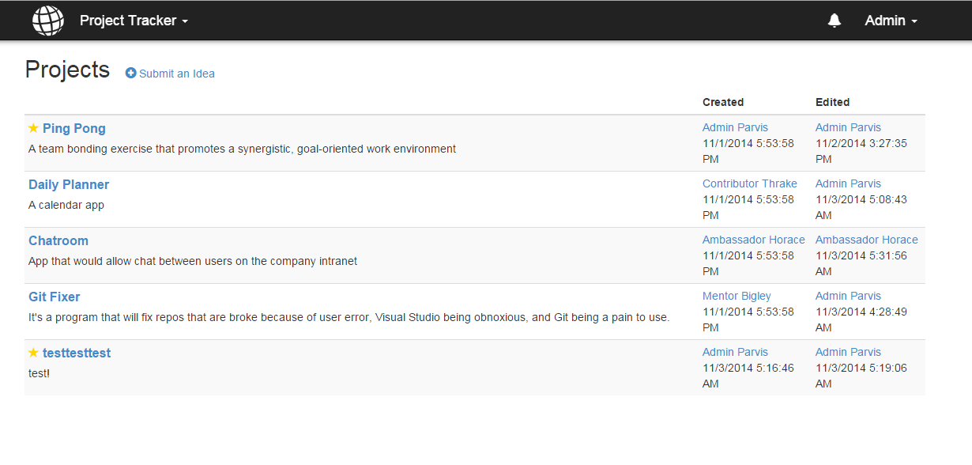

## This picture shows that contributors, ambassadors, and mentors do not have the ability to delete a project, but do have the ability to edit their own.

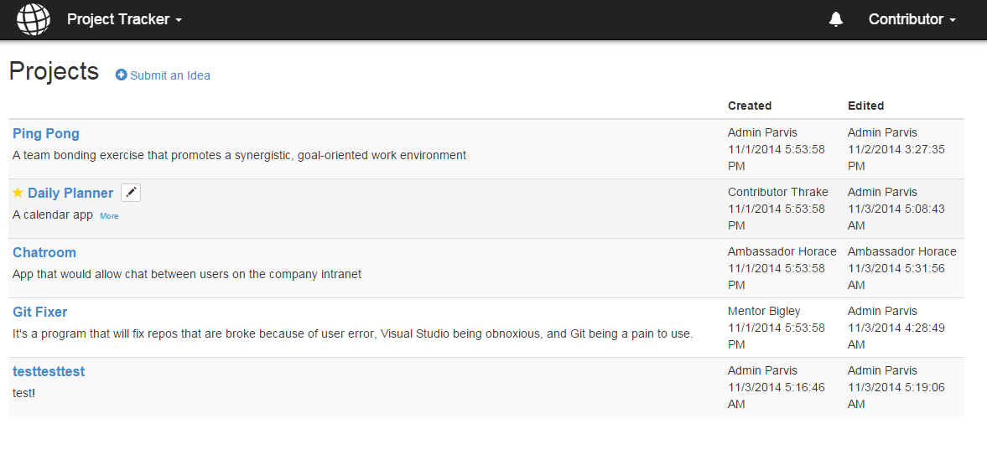

## Admin has the ability to delete any project:

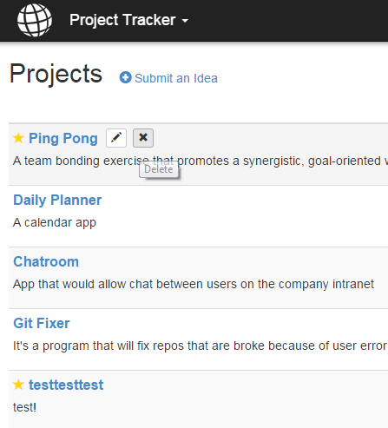

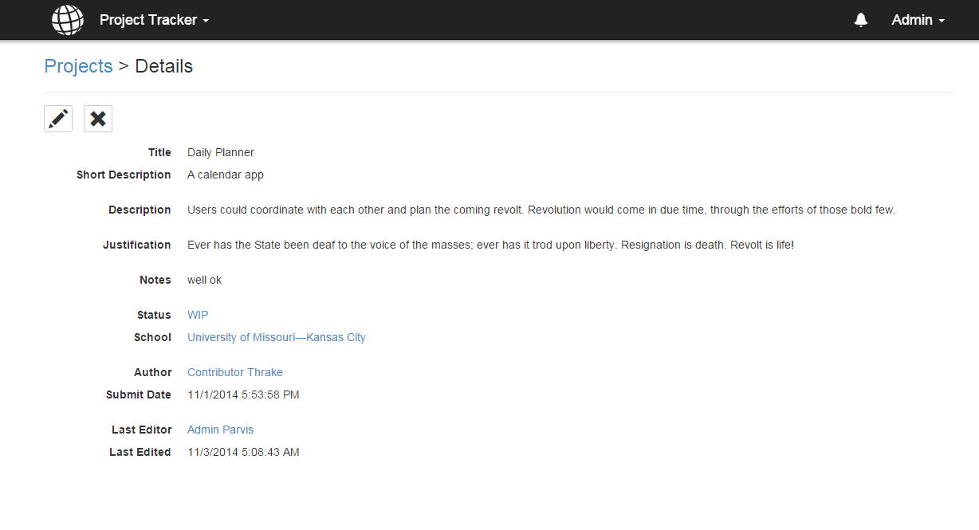

## This picture shows how we improved our deleting functionality. “Are you sure?” confirmation is now on the details page instead of on a separate page:

